**Install ELK Stack on Linux**

**Elasticsearch Installation:**

**Install Java8**

[root@ip-172-31-23-206 opt]# yum install java-1.8.0-openjdk-src.x86_64

[root@ip-172-31-23-206 opt]# java -version

openjdk version "1.8.0_212"

OpenJDK Runtime Environment (build 1.8.0_212-b04)

OpenJDK 64-Bit Server VM (build 25.212-b04, mixed mode)

**1. Import the Elasticsearch public GPG key to the rpm package manager:**

[root@ip-172-31-23-206 opt]# rpm --import http://packages.elastic.co/GPG-KEY-elasticsearch

**2. Configure the repo**

[root@ip-172-31-23-206 opt]# vi /etc/yum.repos.d/elasticsearch.repo

[Elasticsearch]

name=Elasticsearch repository

baseurl=http://packages.elastic.co/Elasticsearch/2.x/centos

gpgcheck=1

gpgkey=http://packages.elastic.co/GPG-KEY-Elasticsearch

enabled=1

**3. Install the Elasticsearch package.**

[root@ip-172-31-23-206 opt]# yum install -y elasticsearch

**4. Start and enable the service**

[root@ip-172-31-23-206 opt]# systemctl daemon-reload

[root@ip-172-31-23-206 opt]# systemctl enable elasticsearch

[root@ip-172-31-23-206 opt]# systemctl start elasticsearch

**5. Allow traffic through TCP port 9200 in your firewall:**

[root@ip-172-31-23-206 opt]# firewall-cmd --add-port=9200/tcp

success

[root@ip-172-31-23-206 opt]#

[root@ip-172-31-23-206 opt]# firewall-cmd --add-port=9200/tcp --permanent

success

[root@ip-172-31-23-206 opt]#

**6. Check if Elasticsearch responds to simple requests over HTTP**

[root@ip-172-31-23-206 opt]# curl -X GET http://localhost:9200

{

"name" : "Mephisto",

"cluster_name" : "Elasticsearch",

"cluster_uuid" : "nLTF7EFhR4e_pC6yyMqocQ",

"version" : {

"number" : "2.4.6",

"build_hash" : "5376dca9f70f3abef96a77f4bb22720ace8240fd",

"build_timestamp" : "2017-07-18T12:17:44Z",

"build_snapshot" : false,

"lucene_version" : "5.5.4"

},

"tagline" : "You Know, for Search"

}

[root@ip-172-31-23-206 opt]#

**This completes the installation of Elasticsearch!!!**

**Logstash Installation:**

**1. Insert the following lines to the repository configuration file**

vi /etc/yum.repos.d/logstash.repo

[logstash]

name=Logstash

baseurl=http://packages.elasticsearch.org/logstash/2.2/centos

gpgcheck=1

gpgkey=http://packages.elasticsearch.org/GPG-KEY-elasticsearch

enabled=1

**2. Install the Logstash package:**

[root@ip-172-31-23-206 opt]# yum install logstash

3. Add a **SSL** certificate based on the IP address of the ELK server at the following line below the [ v3_ca ] section in /etc/pki/tls/openssl.cnf:

[ v3_ca ]

subjectAltName = IP: <add your ip here>

**3. Generate a self-signed certificate valid for 365 days:**

[root@ip-172-31-23-206 opt]# cd /etc/pki/tls

[root@ip-172-31-23-206 tls]# openssl req -config /etc/pki/tls/openssl.cnf -x509 -days 3650 -batch -nodes -newkey rsa:2048 -keyout private/logstash-forwarder.key -out certs/

Generating a RSA private key

.......................+++++

...............+++++

writing new private key to 'private/logstash-forwarder.key'

-----

Can't open certs/ for writing, Is a directory

140609650313024:error:02001015:system library:fopen:Is a directory:crypto/bio/bss_file.c:72:fopen('certs/','w')

140609650313024:error:2006D002:BIO routines:BIO_new_file:system lib:crypto/bio/bss_file.c:81:

[root@ip-172-31-23-206 tls]#

**4. Configure Logstash input, output, and filter files:**

**Input**: Create /etc/logstash/conf.d/input.conf and insert the following lines into it. This is necessary for Logstash to “**learn**” how to process beats coming from clients. Make sure the path to the certificate and key match the right paths as outlined in the previous step:

[root@ip-172-31-23-206 tls]# vi /etc/logstash/conf.d/input.conf

input {

beats {

port => 5044

ssl => true

ssl_certificate => "/etc/pki/tls/certs/logstash-forwarder.crt"

ssl_key => "/etc/pki/tls/private/logstash-forwarder.key"

}

}

Output (/etc/logstash/conf.d/output.conf) file:

[root@ip-172-31-23-206 tls]# /etc/logstash/conf.d/output.conf

output {

elasticsearch {

hosts => ["localhost:9200"]

sniffing => true

manage_template => false

index => "%{[@metadata][beat]}-%{+YYYY.MM.dd}"

document_type => "%{[@metadata][type]}"

}

}

Filter (/etc/logstash/conf.d/filter.conf) file. We will log syslog messages for simplicity:

[root@ip-172-31-23-206 tls]# vi /etc/logstash/conf.d/filter.conf

filter {

if [type] == "syslog" {

grok {

match => { "message" => "%{SYSLOGLINE}" }

}

date {

match => [ "timestamp", "MMM d HH:mm:ss", "MMM dd HH:mm:ss" ]

}

}

}

**5. Verify the Logstash configuration files.**

# [root@ip-172-31-23-206 tls]# service logstash configtest

Configuration OK

**6. Start and enable logstash**

[root@ip-172-31-23-206 tls]# systemctl daemon-reload

[root@ip-172-31-23-206 tls]# systemctl start logstash

[root@ip-172-31-23-206 tls]# systemctl enable logstash

logstash.service is not a native service, redirecting to systemd-sysv-install.

Executing: /usr/lib/systemd/systemd-sysv-install enable logstash

[root@ip-172-31-23-206 tls]#

**7. Configure the firewall to allow Logstash to get the logs from the clients (TCP port 5044)**

[root@ip-172-31-23-206 tls]# firewall-cmd --add-port=5044/tcp

success

[root@ip-172-31-23-206 tls]# firewall-cmd --add-port=5044/tcp --permanent

success

[root@ip-172-31-23-206 tls]#

**This completes Logstash Installation!!!**

**Kibana Installation:**

**1. Configure the repo for Kibana**

[root@ip-172-31-23-206 tls]# vi /etc/yum.repos.d/kibana.repo

[kibana]

name=Kibana repository

baseurl=http://packages.elastic.co/kibana/4.4/centos

gpgcheck=1

gpgkey=http://packages.elastic.co/GPG-KEY-elasticsearch

enabled=1

**2. Install the Kibana Package**

[root@ip-172-31-23-206 tls]# yum install -y kibana

**3. Start and enable Kibana**

[root@ip-172-31-23-206 tls]# systemctl daemon-reload

[root@ip-172-31-23-206 tls]# systemctl start kibana

[root@ip-172-31-23-206 tls]# systemctl enable kibana

Synchronizing state of kibana.service with SysV service script with /usr/lib/systemd/systemd-sysv-install.

Executing: /usr/lib/systemd/systemd-sysv-install enable kibana

Created symlink /etc/systemd/system/multi-user.target.wants/kibana.service → /usr/lib/systemd/system/kibana.service.

[root@ip-172-31-23-206 tls]#

**4. Make sure you can access access Kibana’s web interface from another computer (allow traffic on TCP port 5601):**

[root@ip-172-31-23-206 tls]# firewall-cmd --add-port=5601/tcp

success

[root@ip-172-31-23-206 tls]# firewall-cmd --add-port=5601/tcp --permanent

success

[root@ip-172-31-23-206 tls]#

**5. Launch Kibana (http://192.168.0.29:5601) to verify that you can access the web interface:**

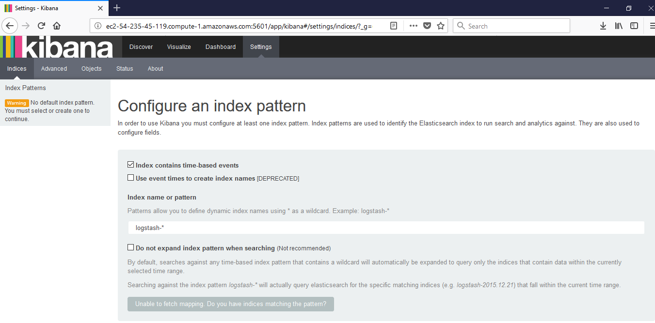

**Install Filebeat on the Client Servers**

We will show you how to do this for **Client #1** (repeat for **Client #2** afterwards, changing paths if applicable to your distribution).

**1.** Copy the SSL certificate from the server to the clients:

[root@ip-172-31-23-206 tmp]# scp /etc/pki/tls/certs/logstash-forwarder.crt [root@3.88.85.40:/etc/pki/tls/certs/](mailto:root@3.88.85.40:/etc/pki/tls/certs/)

2. Import the **Elasticsearch** public GPG key to the rpm package manager

rpm --import http://packages.elastic.co/GPG-KEY-elasticsearch

3. Create a repository for **Filebeat on the Client**

**vi** /etc/yum.repos.d/filebeat.repo

[filebeat]

name=Filebeat for ELK clients

baseurl=https://packages.elastic.co/beats/yum/el/$basearch

enabled=1

gpgkey=https://packages.elastic.co/GPG-KEY-elasticsearch

gpgcheck=1

4. Install the **Filebeat** package:

[root@ip-172-31-94-89 ~]# yum install filebeat

5. Start and enable Filebeat:

[root@ip-172-31-94-89 ~]# systemctl start filebeat

[root@ip-172-31-94-89 ~]# systemctl enable filebeat

Created symlink from /etc/systemd/system/multi-user.target.wants/filebeat.service to /usr/lib/systemd/system/filebeat.service.

[root@ip-172-31-94-89 ~]#

#### Configure Filebeat

A word of caution here. **Filebeat** configuration is stored in a **YAML** file, which requires strict indentation. Be careful with this as you edit /etc/filebeat/filebeat.yml as follows:

1. Under **paths**, indicate which log files should be “shipped” to the ELK server.
2. Under **prospectors**:

input_type: log

document_type: syslog

1. Under **output**:
   1. Uncomment the line that begins with **logstash**.
   2. Indicate the IP address of your ELK server and port where Logstash is listening in **hosts**.
   3. Make sure the path to the certificate points to the actual file you created in **Step I** (**Logstash** section) above.

The above steps are illustrated in the following image:

[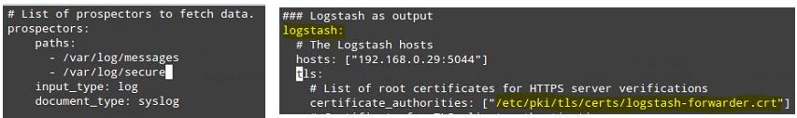](https://www.tecmint.com/wp-content/uploads/2016/09/Configure-Filebeat-in-Client-Servers.png)

Save changes, and then restart **Filebeat** on the clients:

[root@ip-172-31-94-89 ~]# systemctl restart filebeat

#### Testing Filebeat

In order to verify that the logs from the clients can be sent and received successfully, run the following command on the **ELK** server:

# curl -XGET 'http://localhost:9200/filebeat-*/_search?pretty'

The output should be similar to (notice how messages from **/var/log/messages** and **/var/log/secure** are being received from **client1** and **client2**):